Project Management Concepts

- Project vs. Operations
  - Projects = a new venture that does not yet exist
  - Operations = repeatable steps
  - Two different skill sets

- Phases of Project
  - Business Planning / Dreaming
  - Warming Up the Project
  - HOT Project = ACTION
  - Wrap Up and follow through = Closing the Project

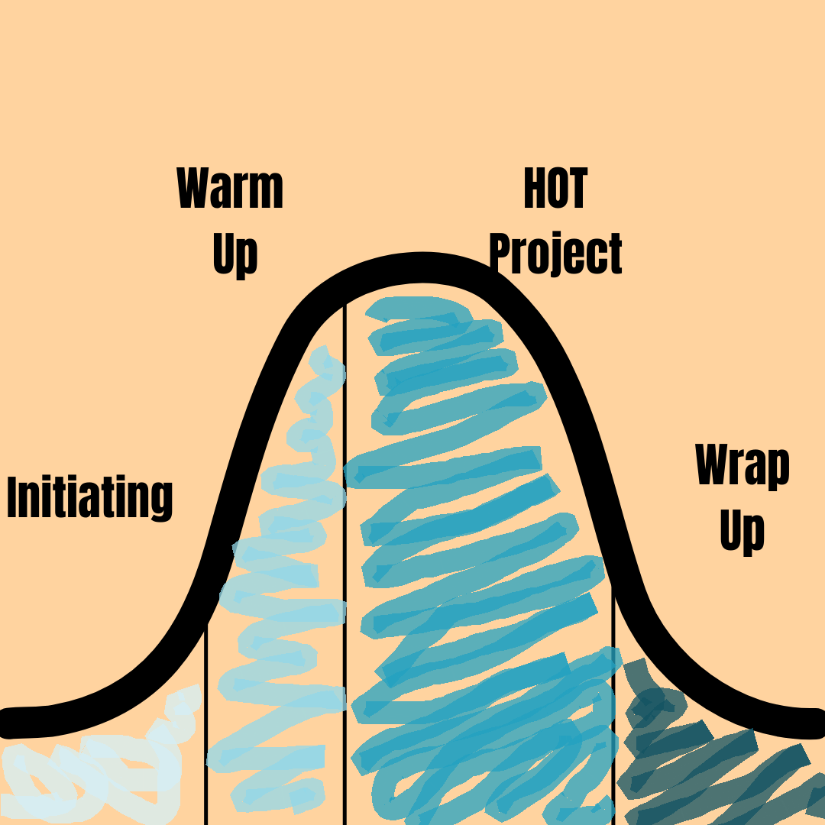

- Communication
  - The primary responsibility of the project manager – hire for this ability
  - Over communication is ideal
  - Most problems in the project will come as the result of miscommunication or the details not being as clear as you’re assuming they are
    - Keeping “Assumptions” as a part of the conversation and discussing openly what you’re assuming helps minimize miscommunications.
    - Recommend Video: Why Can’t I Speak the Way I Do in My Mind
  - Social Media: key for communicating with your most important Stakeholder: the community
  - Document Sharing Solution – Google Drive, Sharepoint, etc.

- Project Scope
  - Idea Wall Tool & Technique
  - “Scope Creep”
  - “Mission Critical” or “After Opening”
  - Continually reassess as you get closer to opening

- Rolling Wave Planning
  - Progressive Elaboration
  - Plan in detail the current phase, the next 1-4 weeks
  - Plan loosely areas of the project that are further away than that
  - As you make progress, plan the next upcoming section in more detail

- Requirements vs. Tasks –
  - Template: Mod1_5 Task Tracking & Scheduling Dependencies
  - “Begin with the End in Mind” – Figure out the end and work your way backwards to create the list of what needs done
  - Get specific about the vision –“Bakery” gets broken down into: fresh-baked cinnamon rolls, breads, cookies, scones, custom cake orders, cupcakes, thaw and sell items, and other custom party trays.
  - Other terms to know
    - Constraints
      - We don’t intend to upgrade the electrical so the oven will have to be below #### power threshold
    - Dependencies
      - Example: the floor can’t be stained and finished until the plumber is done cutting into the floor to lay the plumbing for the refrigeration units
    - Traceability
      - Who requested each individual requirement - if you run into time / budget issues - this is your point of contact to follow back up with for more information, to delay or eliminate the item from the project scope.

  - Requirements vs. Tasks
    - Requirement: Purchase oven for bakery
    - Tasks:
      - Discuss oven specs with grocery warehouse or other trusted source – get recommendations for both new and used equipment
      - Research used ovens
      - Get quotes on new ovens
      - Consult with electrician on electrical updates that may be needed
      - Compare used options with new quotes and decide which to purchase
      - Once decided, provide oven specs to electrician to confirm/finalize electrical updates that may be needed
      - Receive oven in store and schedule with proper contractor for installation
      - Once installed, confirm the oven is working for its intended purpose
      - Make sure appropriate personnel is trained in how to use the oven
  - Task List
    - Use ID numbers on tasks to track details, due dates, team members assigned, priority level, etc.

- Budget Management
  - Budget for Time = Timeline / Dependencies

  - Budget for Money
    - Quotes, quotes, quotes is how you build your budget and make sure it all fits together
      - Quotes give you estimates for time, money, and dependencies
        - Example: if a contractor is the cheapest, but can’t fit you in until next year, you may need to select a more expensive quote to fit your timeline requirements
      - From the quotes you can build the “Budget” and “Schedule”

- Stakeholders –
  - Template: Mod1_4 Stakeholder Tracking
    - Name, Phone, Email
    - Types of Stakeholders
      - Project Team
        - Contractors
        - Employees
      - Community Members
      - Abstract SH like “the community”
        - Begin the relationship with the community ASAP/as soon as you’re “Ready”
          - “Readiness” – the clock on the financing is ticking and this is THE MOST IMPORTANT relationship your store has, knowing how to say “I don’t know yet” will speed up your readiness.
    - Project Role
    - Priority/Importance

- Professional & Advisory Support
  - Banker
  - Insurance Agents
  - Consultants
  - Board of Directors
  - Attorney
  - Accountant
  - Business / Personal Mentors

